Teacher’s Conference Evaluation Report:

VENUE: MJ GATEWAY, POLOKWANE

Theme: “Working together promoting sustainability”

AIM:

The aim of the teacher’s conference was to offer a unique opportunity for teachers and other stakeholders to engage in environmental issues such as invasive alien plants, water related issues, climate change and global warming, biodiversity and integrated waste management, in an environment that is conducive for learning.

The WfW teachers’ conference aims to do this by fulfilling the following objectives:

Objectives of the Conference

Working for Water Teachers Conference will serve as a vehicle to bring greater awareness of the growing threat of “alien” invasion on our water resources and biodiversity as well as other environmental issues. The conference also encourages the Teachers of South Africa:

- To align themselves to International, National and Regional initiatives such as the United Nations Decade of Education for sustainable Development (UNDESD)
- To recognise and award Environmental Education (EE) and Environmental Education for Sustainable Development (ESD) initiatives and programmes, promote environmentally related careers opportunities
- To enhance their interest in IAP and Water Management careers which would allow them to motivate learners to follow those careers
- To promote the study of IAP, Science and Technology, water education and the water related environments
- To provide opportunities for networking, promotion and showcasing of EE & ESD programmes, learning support materials and activities, sustainable technologies and environmental management practices from partner organisations.

The Aims and Objectives for this Teachers Conference were definitely met.

Focus of the Conference

The 2010 Teachers Conference was different to the previous year, as last year we focused solely on the impacts of invasive alien plants. Whereas this year we took a more holistic approach to dealing with environmental issues that impact our environment.

Specific Themes / Categories for 2010’s conference
- The impact of invasive alien plants on social livelihoods/ natural environments/water systems
- Climate Change/Global Warming
- Biodiversity
- Water Conservation
- Waste Management

Day 1

Mr. Donovan Fullard, Deputy Director (DD) of SANBI Environmental Education Empowerment was the Programme Director for the entire National Teachers’ Conference. He did an excellent job and participants could learn a lot from him. 130 participants participated in the National Teachers’ Conference.

Programme Director in Action
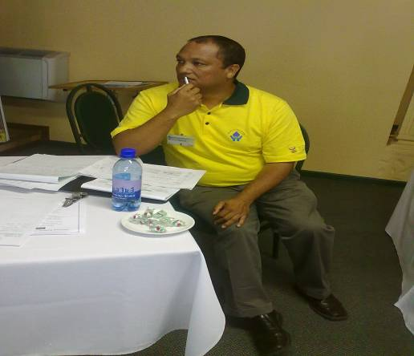

It was intended that the Chief Director of DWA in Polokwane open the event, however due to other commitments the Director of DWA opened the ceremony on his behalf. The Director congratulated Working for Water Programme (WfW) for embarking on such an initiative.

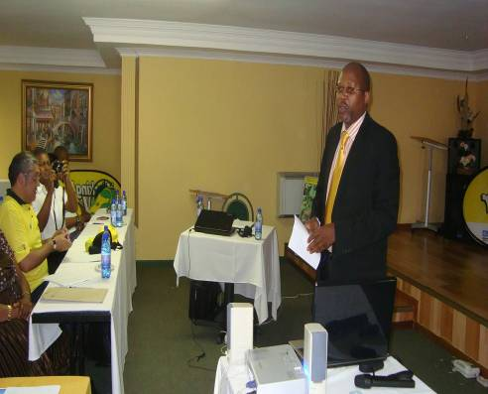

Mr. Mobayi

Mr. Mobayi, Chief Education Specialist of Department of Education in Polokwane did the opening address and expressed the need for a collaborative effort by all the relevant departments and NGO’s to address the global issues affecting the environment. He stated that in a well researched paper on invasive alien plants, Richardson and Wilgen, argue that “Besides their effects on agriculture, forestry and human health, biological invasions are also widely recognized as the second-largest global threat (after direct habitat destruction) to Biodiversity.” Hence the importance of raising awareness amongst society is highly important.

(His speech is available)

Officials from the WfW programme and Department of Education (DOE) officials were used to Chair the different sessions and worked collaboratively as a team.

Last year all presentations took place in one hall, this year the presentations took place in 3 different halls and teachers could select which sessions they want to sit in.

Day one was quite hectic, because teachers could only give us their presentations the morning of the National Teachers’ Conference (NTC). This was very stressful for the Programme Director and the Project Manager. On the programme we were suppose to use 3 halls for teachers to present. This did not happen, because some of the schools that were supposed to present on day one arrived at the venue late afternoon. The organizing committee then took the decision to adapt the programme and only used 2 halls.

16 Presentations were presented on day 1 focusing on the following environmental issues:
- Negative impacts of Invasive Alien Plants (IAPs) on our environment, breeding biological control agents for Water Hyacinths, waste management, impacts of IAPs on the lives of people, factors threatening our water resources in the community, invasive alien plants, biodiversity, promoting environmental education, impacts of IAPs on the lives of people, cholera outbreak at school, greening projects and impacts of IAPs on our water systems.

The day ended on a high note and teachers and participants could not stop talking about the great projects that were presented and the knowledge that they had gained from the presenters. A lot of learning took place and it was indeed an eye opener for all of us. Teachers could engage on the topics further in their spare time which also allowed them the opportunity to network.

Day 2

Innocent Ntshai, Mapela Mailman, and Trammeling Marie were the chairs for day 2

Due to some of the schools arriving late the day before, we had to revise the programme again to see how we could accommodate the teachers that had missed out. We had to be flexible to create opportunities for all teachers to do their presentations.

Mr. Jimmy Sithole giving us an overview of the previous day’s presentations.

Mr. Jimmy Sithole Ms. Denecia Myburgh

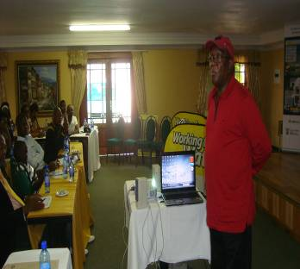
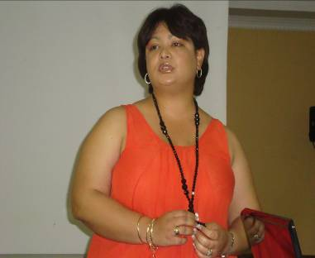
Ms. Denecia Myburgh did a presentation on their Departmental perspective of Invasive Aquatic Weeds”. The project presented focused on their involvement with the Warrenvale High School in the Northern Cape’s Aquatic Weeds Project. It was great to see that officials from DOE also presented projects linked to IAPs. She also presented lesson plans developed by the officials focusing on Life Sciences. This session was very fruitful and meaningful. Lots of questions were raised and teachers appreciated the presentation. This presentation also motivated Curriculum Advisors from other regions, as they mentioned that they would like to present next year.

After tea teachers went to their different halls to listen to other projects and present their projects.

26 Presentations were presented on Day 2 focusing on the following environmental issues:
- Saving water, Black Wattle clearing project, Eco-schools project, climate change, waste management, IAPs in Knysna and its impacts, impacts of hunger in our environment, environmental restoration within the school curriculum, negative impacts of IAPs, multi purpose water recycling, perma –culture, carbon footprint, pollution as an impact on social livelihood, biodiversity, invasive alien plants species, impacts of IAPs on our natural environment, impacts of IAPs on the lives of people, negative impacts of IAPs on our environment, invasive alien plants – control programme, eradication of IAPs – replaced by vegetable gardens.

A 13 year old Grade 8 learner from Vhufamadi High did a presentation on the impacts of IAPs. He was very knowledgeable, confident and passionate about IAPs. This really showed that teachers are transferring the knowledge and skills that they had gained on IAPs to their learners and colleagues.

Day 3

The first session consisted of a series of presentations where all participants met in Hall 1. Welcome and opening was done by the Programme Director. Jimmy Sithole did an overview of Day 2. Ahmed Khan then did a presentation on the Natural Resource Management programme. After that Debbie Sharp did a presentation on Bio-control.

A student of the University presented their project on Biodiversity and Ants.

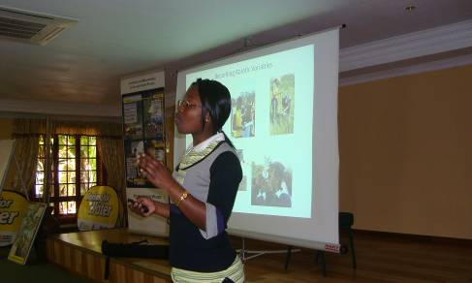

Teachers were very interested in all the above topics. They wanted to know more about these issues.

Session 2:

Fadli Wagiet (DOE), Collen Martheze (WfW WC Reg.) and Rowan Lamont (WfW NO) chaired the sessions for the day.

14 Presentations were presented on Day 3.
- Biodiversity, impacts of IAPs on our water systems, impacts of IAPs on the lives of people, negative impacts of IAPs on our environment, growing vegetables in support of orphans and vulnerable children at school, IAPs and the School Curriculum, Working on Fire Education Project, negative impacts of IAPs on social life.

Site Visit

After lunch the participants departed to Haenertzburg on a Site Visit. The site visit was one of the requests of the 2009 NTC. Thanks to the region and the regional conference project manager Agnes Gafane, as they made it possible for us to go on a site visit. Participants went into the field where they experienced what WfW workers are doing in the field. Most of the participants have a greater respect for them now after experiencing what it is like working in the field. Many questions were posed from which field workers answered with pride

Award Ceremony

The Chief Education Specialist joined us to award the teachers with their certificates. Teachers were so excited and the mere fact that the certificates were framed was very valuable for them. The presentation of the certificate made them feel as if they were part of something big and they had a strong sense of pride. The fact that the teachers from the different regions also asked us to join them in the group photo’s showed that they valued our input for the week.

Mr. Mobayi, Chief Education Specialist welcomed the participants followed by the National Anthem. Jimmy Sithole then did an overview of the entire National Teachers’ Conference

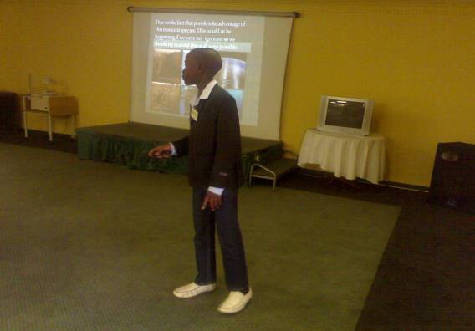

Vumboni Msimango (Master) Limpopo’s young dynamite, a 13 year old grade 8 learner who did a presentation on the impacts of IAPs on our natural environment gave us an overview of his perspective of the conference. He applauded the organizers and stated that he learnt a lot, but would appreciate it if we can include learners for the 2011 Teachers’ Conference.

A teacher of Vhfamadi High school read a poem on invasive alien plants

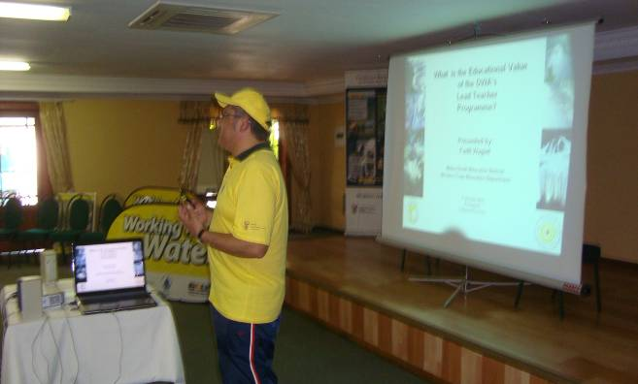

Mr. Wagiet did a presentation DWA (WfW) contribution to the Millennium Development Goals (MDG) and the Decade for Education and Sustainable Development (DESD). It was a very informative presentation and participants thanked him for the valuable and educational presentation.

This is what he stated:

I Believe that the DWAs Lead Teachers are part of a WORLD COMMUNITY trying to improve the quality of life of all citizens by promoting the values of ecological sustainability and social justice in engaging in environmental projects that develop the abilities of learners to take informed action for a healthier environment for all South Africans

I SALUTE YOU

The Western Cape (WC) teachers did a drama focusing on IAPs. The audience was so excited and gave them a standing ovation. An overview of the NTC from a teachers’ perspective was done by Mr. Siguba and he could not thank WfW enough for creating this opportunity for teachers. He mentioned that he could not wait to get back to his region to set up meetings with teachers and share the knowledge that he gained.

Debbie Sharp gave a speech from the WfW side and Florence Gamanie thanked all the participants and partners for their valued contribution in making the 2010 National Teachers’ Conference such a major success.

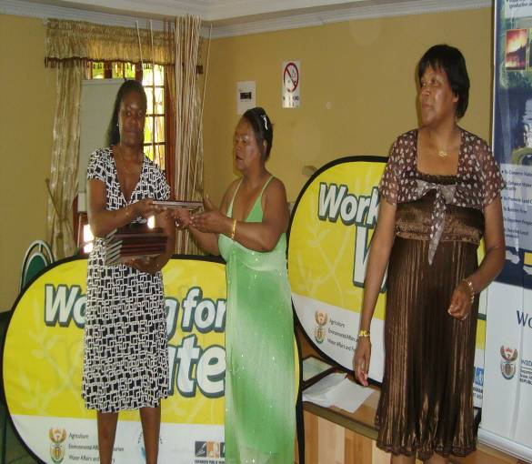

After the Award Ceremony Werner Roux thanked all participants for a wonderful and fruitful National Teachers’ Conference.

Issues that emerged from the Teachers Conference

Partnership

Partnership is one solution to address the environmental and educational challenges we have at present, as it is a way of supporting teachers in a more sustained and systemic way. Lack of partnerships was one of the key issues raised at last year’s conference. However this year you could clearly see that teachers made use of partners in their regions, as they communicated this in their presentations.

Poverty was also highlighted on numerous occasions. The need for vegetable gardens, concerns about Cholera and other diseases,. sanitation, shortage of water was also noted a common problems in schools.

Positives

After the National Teachers’ Conference I’ve liaised with Department of Education Head Office and they agreed that they will put all the presentations, photo’s and information related to our National Teachers’ Conference on their website. This will allow all teachers in SA to access it and can be seen as awareness raising.

According to Mr. Jimmy Sithole Gauteng DOE specialist, the level of professionalism of teacher’s presentations was very high. There was a Buzz and excitement of wanting to know more after each presentation. He mentioned that when you go to other conferences nationally or internationally there is a tendency where participants leave the conference to do shopping, but what was great about this conference was the fact that you never had a single teacher leaving the premises. This shows the high interest that they had in the environmental education projects.

The WfW National Teachers’ Conference is taking the place of the Department of Basic Education (DOBE) School Choir where teachers had the opportunity to network with each other. This is not happening anymore and thanks to WfW, teachers nationally have the opportunity to come together, share and network their projects. It has also provided an opportunity for DOE officials nationally to engage with one another. WfW was applauded WfW for the initiative. Participants felt that Mr. Sithole should become a Patron of the National Teachers’ Conference for his commitment as there is so much that everyone can learn from him.

It was highlighted that if you look at the projects presented last year and compare it with this year you could see that development of teachers took place and that there was a dramatic improvement and knowledge base of teachers’ science knowledge because they were spot on with their knowledge related to invasive alien plants. You could see that the teachers were also much more confident this year in presenting their projects.

What was great was that the teachers that presented last year sustained their projects. Major improvement and networking was evident in the projects. You could see that most of the schools had their community involved with their projects which is positive, because they also raised awareness amongst them. Magane Primary School of Limpopo explained how they set up a meeting with their Department of Education after last years conference to share and highlight their project as well as knowledge related to invasive alien plants that they’ve gained. They then informed DOE that they would like to share the knowledge that they’ve gained with other teachers in their surrounding area. The officials from DOE then send out invitations to the schools in their surrounding area. 17 Schools attended the invasive alien plants workshop that was facilitated by the school and they brought in WfW contractors to assist them. This is definitely a major milestone and this is what we would like to see happening at all the participating schools. An EC teacher mentioned that he never thought it would be possible for one teacher to equip one another, but at the conference he learnt from other schools that it is possible.

In the WC, teachers have the experience where a partnership was formed amongst WfW, 2020 Vision for Water Schools Education Programme (VFWSEP), SANBI, Metropole South Department of Education, Cape Nature and the City of Cape Town. It was proven that as partners we can work together and support teachers by means of sharing our resources, knowledge and experiences. This is definitely a success story. The different partners supported the teachers in preparation for the National Teachers’ Conference and the projects presented from this region were of a very high standard due to the support from partners. Thanks to the City of Cape Town which provided us with the bags for the teachers’ conference.

This year partners of different organizations e.g. Wessa, WoF, University of Stellenbosch, SANBI , Eco Schools and WfW officials had the opportunity to participate in the conference and present their projects. Teachers highly appreciated it because this was an opportunity for them to engage with different partners. Partners also shared their expertise, knowledge and resources related to the projects, which teachers can use in their classroom to enhance their learning. Partners gave up their valuable time to be part of this conference, because they saw the value of the conference.

It was great to have the Regional Programme Leaders, Aadiela Moerat and Werner Rossouw at the conference as a support system. They were very committed and supported us whenever help was needed from day one until the very last day. They also played a vital role by chairing and recording some of the daily activities for us. It is great to know that you have the support of your colleagues in the regions. They bring value to the conference and add to the sustainability and the success of it.

The Eco-Schools teachers from the WC also presented at the conference. They had the opportunity to bond with the WC Lead Teachers. A positive outcome is that they are going to join the WC Lead Teachers and will form part of our LT group. This is definitely a positive result.

The status of confidence is definitely growing. All the projects presented displayed action. In most of the EE projects learning to do, learning to live together (social issues), learning to be (individuals standing in front of a National forum with a high self esteem) and learning to know (the passport to life long learning) were displayed.

Some presentations were of a higher quality then others, but what was important is the fact that teachers were developed professionally as well as personally. Teachers had the opportunity to bond and engage with one another.

Mr. Fadli Wagiet, education official from WC stated that we should create more opportunities for teachers to build together a sense of comrade as part of development.
Mr. Wagiet spoke about the respect that participants have for one another. The projects was of such a high standard that Mr. Wagiet are in the process of looking for funding for 4 WC teachers to present their project at the World Environmental Education Conference that will be hosted in Australia next year. The intended projects will focus on invasive alien plants, biodiversity, climate change and waste management. This will be an opportunity to put SA on the map.

Two DOE officials from different regions had a discussion regarding the responsibility of DOE to initiate a conference like this and congratulated WfW for coming up with this initiative.

Mr. Donovan Fullard, Deputy did an excellent job as the teachers’ conference programme director. All partners and participants were impressed with the manner in which he handled the conference. They also learnt a lot from his experience related to EE. He stated that the conference created an opportunity for Black disadvantage people to develop in Conference management. Different people played different roles at the conference and this created a safety net. He also mentioned that this conference could be seen as capacity building for previously disadvantaged individuals.

Some presentations were of a higher quality then others, but what was important is the fact that teachers were developed professionally as well as personally. Teachers had the opportunity to bond and engage with one another.

Two DOE officials from different regions had a discussion on the fact that it should have been the responsibility of DOE to initiate a conference like this and congratulated WfW for coming up with this initiative.

Mr. Donovan Fullard, Deputy Director, Environmental Education from SANBI was our programme Director for the entire National Teachers Conference. He did an excellent job and all partners and participants were impressed with the manner in which he handled the conference. They also learnt a lot from his experience related to EE. He stated that the conference created an opportunity for Black disadvantage people to develop in Conference management. Different people played different roles at the conference and this created a safety net and can be seen as capacity building for previously disadvantaged individuals.

Last year Mr. Wagiet captured the events of the day and gave an overview every morning. This year Mr. Jimmy Sithole Gauteng DOE was roped in to play this role and this can also be seen as capacity building.

Looking at the Skills Act we can truly see how the WfW Teachers’ Conference created opportunities for Capacity Building and transfer of skills. WfW National, WfW Regional and DOE officials were used to chair the sessions. This can also be seen as building of capacity amongst partners.

The role that Theresa played as an Administrator and events co-coordinator must be highlighted and can be seen as capacity building. This needs to be recognized and we must grow and develop it further and support one another.

Taking the context of time of the conference into consideration, we came out of a 3 week teachers strike and the issue of whether the conference was still happening or not was a great concern. We were grateful to have 110 teachers present at the conference. The organizers were matured enough to be flexible and adapt, and this does not happen at any conference nationally or internationally. This caused a lot of stress on the Project Manager and Programme Director, but they never complained. This displayed the quality of the organizing team.

Theresa played a major role and took accountability for making sure that teachers and officials were accommodated with rooms. The conference took her to another level and she was trusted to do a very important job as being the registrar for the conference. Her friendliness was welcomed by the participants and partners. She even went the extra mile to instruct our group to wait until all participants departed from the Lodge, before we could leave. This showed commitment until the very last minute from her side. This was a learning experience for her and she saw other opportunities of what she can do. It inspired her so much that she sees the importance of furthering her studies.

There was a request last year that we should include a Site Visit into the programme for the 2010 NTC. We’ve included it for this year and the WfW Regional office was tasked with that project. Thanks to Werner Roux, Agnes Gafane and their team from the regional office who made this possible. Participants were taken to one of the WfW sites in Haenertzburg, where a contractor and team welcomed them. This was a learning experience for the participants and they enjoyed every moment.

Requests:

- WfW should have a Website for their Lead Teachers so that they can engage with one another and share ideas and provide a support system to one another.
- A quarterly newsletter to be distributed to Lead Teachers and other schools to showcase Research Projects and share information related to the programme.
- Regional Conferences should take place to give more teachers the opportunity to participate on a regional level.
- Get Politicians involved and allow them to participate in the National Teachers’ Conference to inspire them to allocate a budget towards this event.
- Place Criteria of NTC on website for teachers to access
- Exhibition to be included as part of the NTC
- Compile guidelines of what is a good quality project and distribute
- Database of schools to be forwarded to all participants

Way Forward

Communicate and liaise with University of Stellenbosch in developing an accredited short course on IAPs and other environmental issues for the WfW Lead Teachers.

Challenges for Institutions and municipalities – There is a major lack of resources in schools on all issues related to the environment. There is a need for other departments and organizations to provide schools with resources. The Teachers’ Conference must be sustainable.

Recognition to Teachers

Recognition should be given to the high performing schools that participated. This must also be brought under the attention of DOE and principals so that it can be included into the teachers’ IQMS (performance appraisal). Teachers need to be acknowledged for giving up their school holidays, as this showed signs of dedication, commitment and perseverance.

A suggestion was made that WfW should look at ways of acknowledging teachers by means of sponsoring them for short EE courses as part of Professional Skills Development that will enhance their skills or think of other ways of acknowledging them. This can be done with the IAP Champion Lead Teachers nationally, in preparation for them to take the process of equipping teachers in their region further. This will also assist WfW Education with the shortage of human capacity that we currently have.

There was a request that WfW selects some of the projects and ask teachers to present at the EESA conference or the World Environmental Education Conference (WEEC) next year. This will allow teachers to share their experiences on an international level.

Compiled: Florence Gamanie

